**Interface Design**

This document will provide a detailed explanation to the design of the user interface to be implemented in the Graphical Enigma Simulator. Various iterations of the design were done throughout implementation. Once a mock-up was created they were then reviewed for enhancements. Finally they were reviewed and the next iteration of prototypes were created.

*Paper Prototypes*

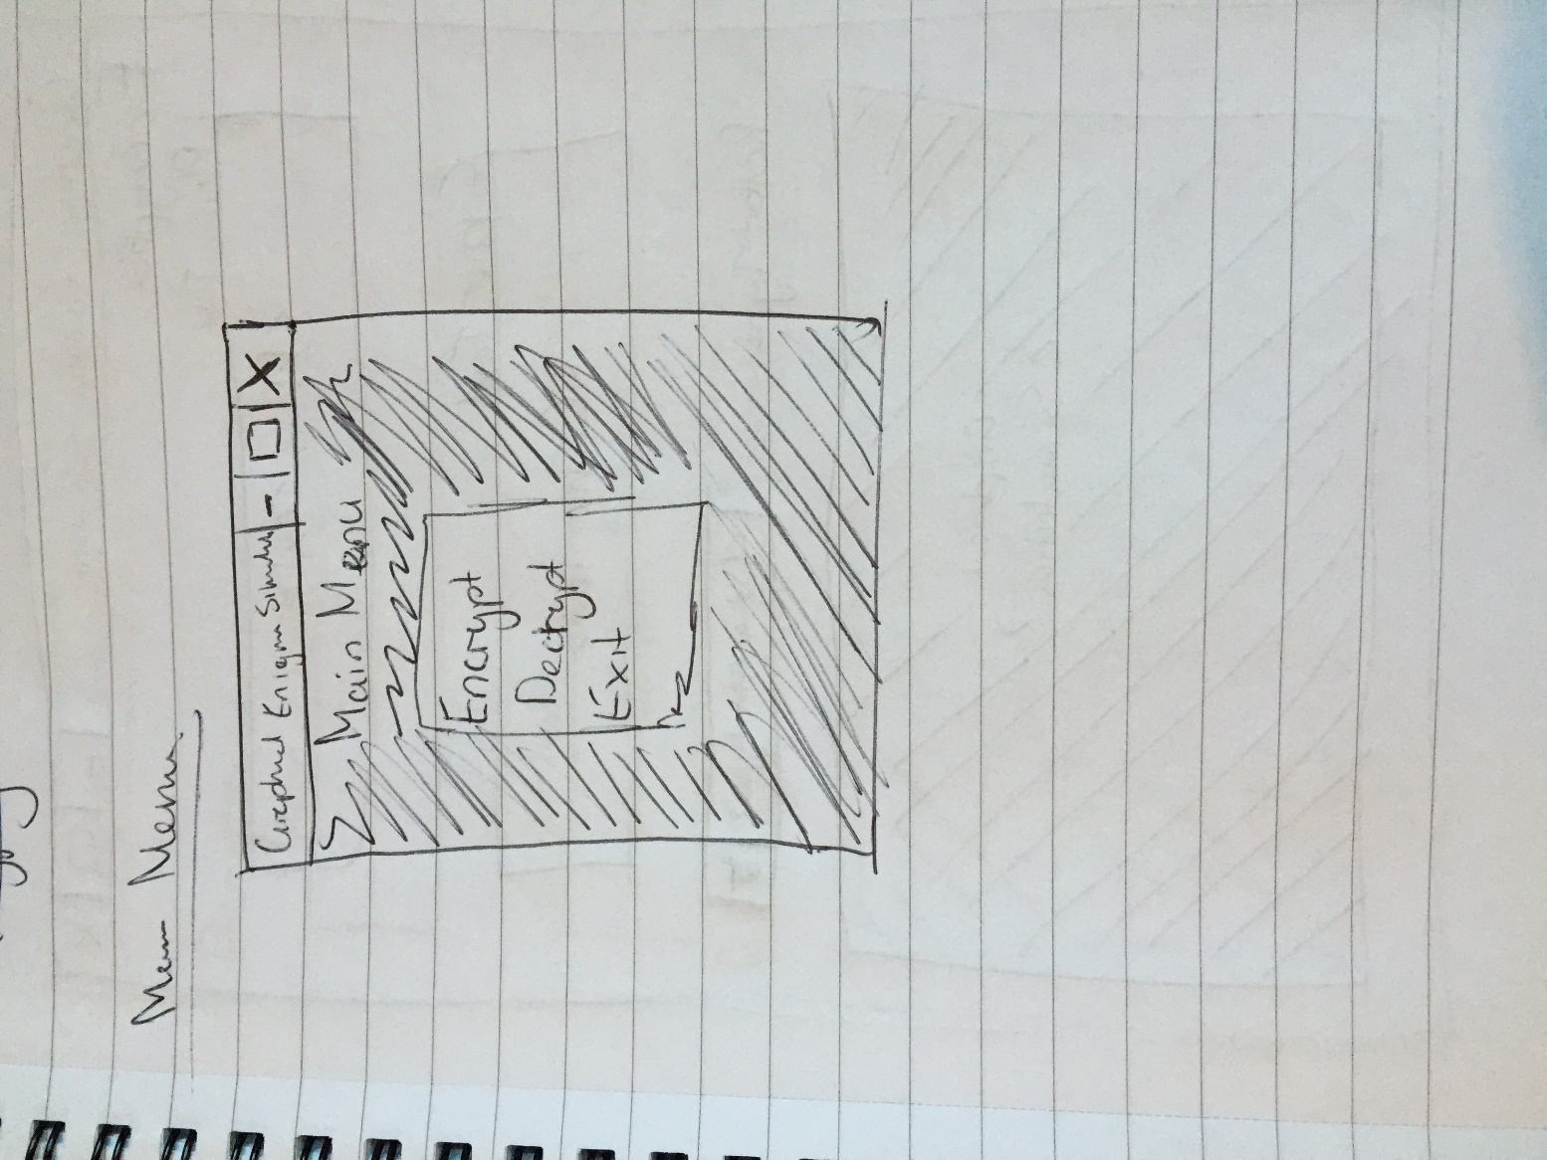

*Figure 1 – Main Menu*

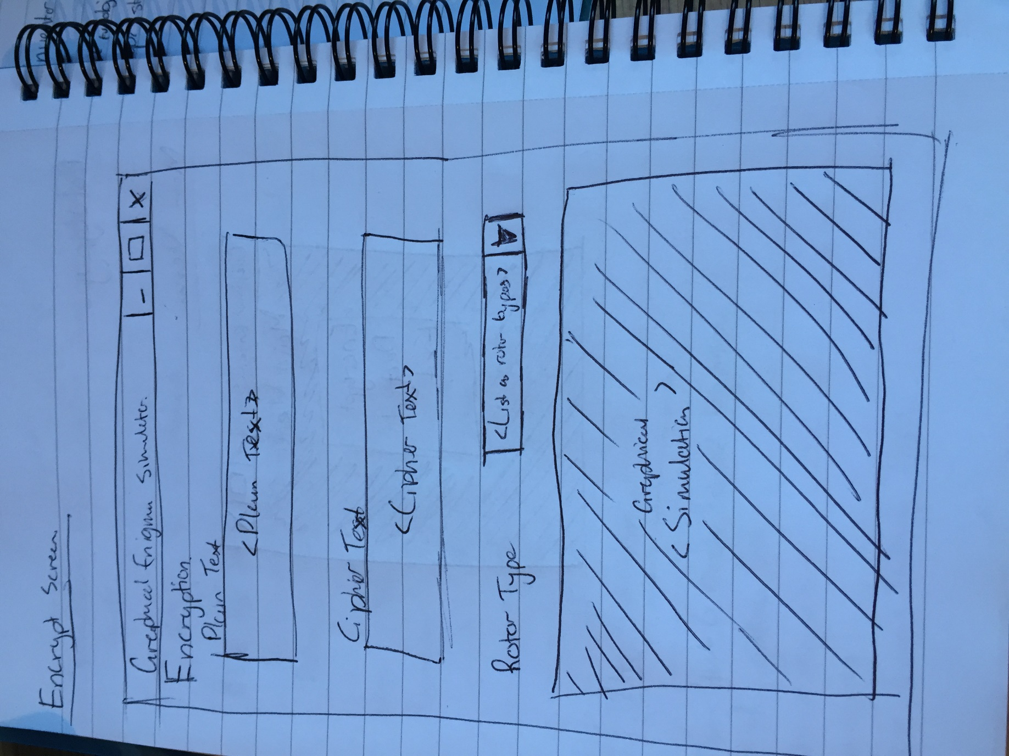

*Figure 1.1 – Encrypt Screen*

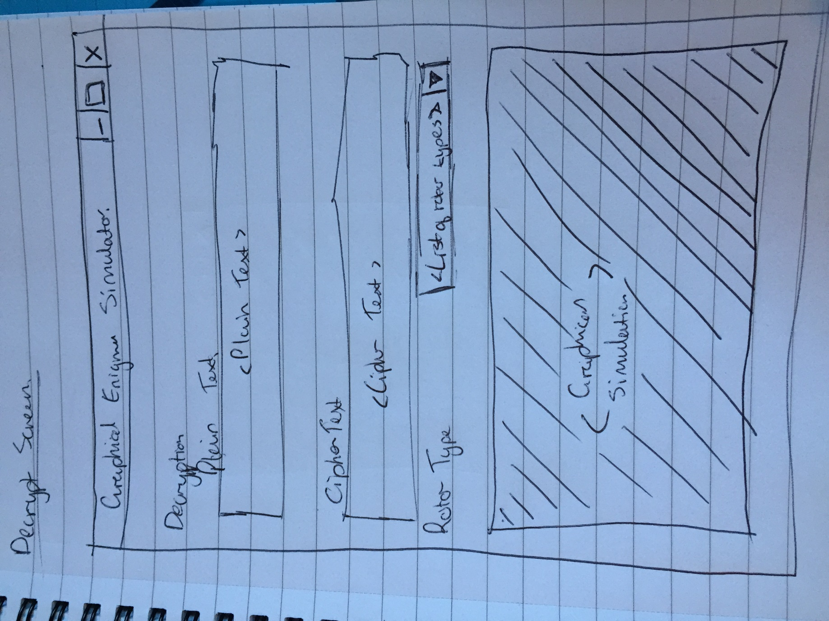

*Figure 1.2 – Decrypt Screen*

Figure 1, represents the layout of the main menu the user shall be presented with upon starting the simulator. The user will then have various options to select from, encrypt, decrypt and exit.

Figure 1.1 represents the layout intended to be implemented in the simulator. The graphical simulation shall be a 3D graphical animation which will clearly demonstrate the encryption process within an Enigma machine.

Due to there being a number of different type of rotors available with different encryption keys, the user will be able to select from a number of different type of rotors.

The user will then enter text in the ‘plain text’ text box. Once the user enters one letter, the graphical simulation will then demostrate the encryption process by animating the current passing through the rotors and then encrypting that letter.

The decrypt screen, Figure 1.2 layout is similar to the encrypt screen, except that the user will be allowed to input their ciphered text and the output will be produced to the plain text field. The graphical simulation will demonstrate the process of decrypting a letter.

*Prototypes – Iteration 1*

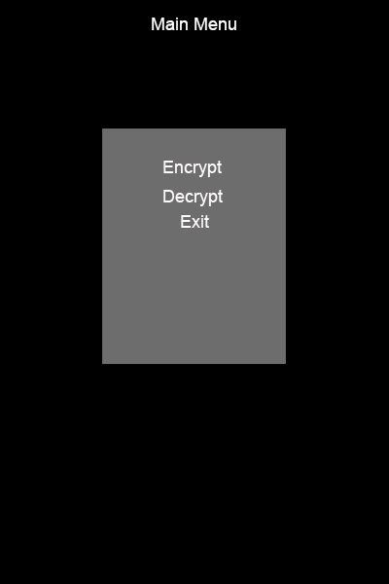

*Figure 2 – Main Menu*

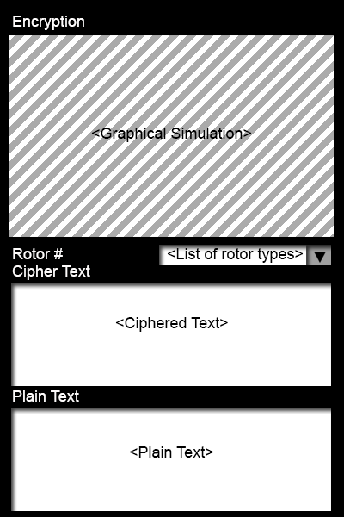

*Figure 2.1 - Encrypt*

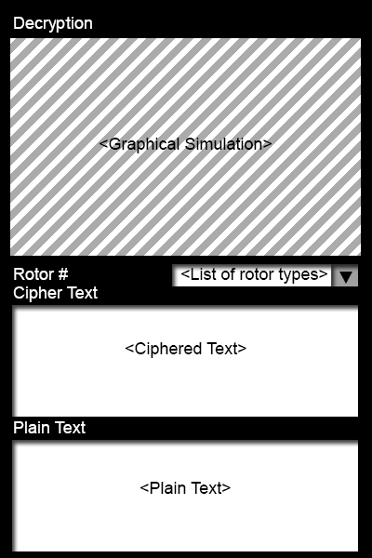

*Figure 2.2 - Decrypt*

During this iteration, graphic based prototypes were created rather than paper prototypes. Refinements were made, however, from the paper prototypes. It was decided that having the graphical simulation at the top of the screen rather than the bottom would be better. Also, the wording of ‘Rotor Type’ did not seem justified therefore it was renamed to ‘Rotor #’.

*Prototypes – Iteration 2*

From review of the previous iteration, it was realised more space would be required for the graphical simulation to be viewable at a relatively good size. Further refinements were made during this iteration.

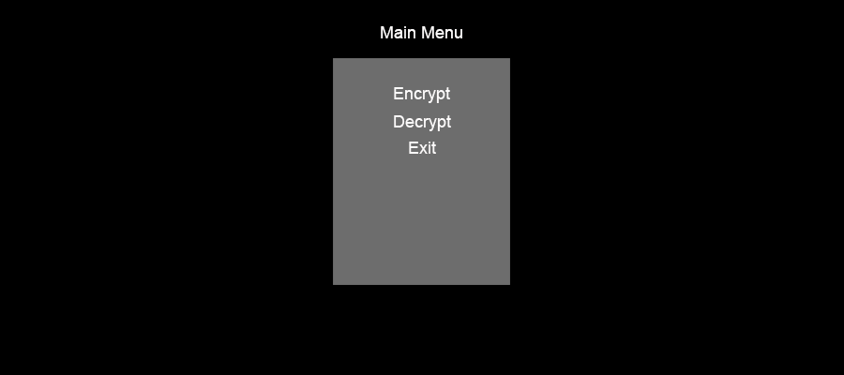

*Figure 3 – Main Menu*

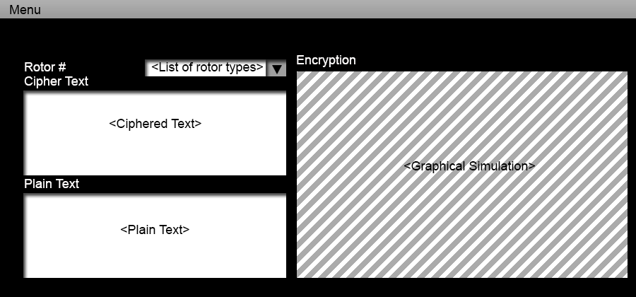

*Figure 3.1 - Encrypt*

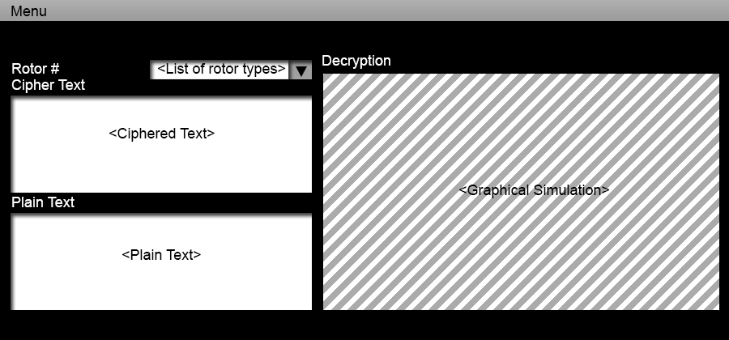

*Figure 3.2 - Decrypt*

The content within the screens would remain the same, with only the screen orientation differing, from portrait to landscape.

*Prototype - Final Iteration*

After much consideration throughout implementation and testing the design concepts changed. It was decided that the orientation should be set to landscape only, however the main menu is unaffected by this.

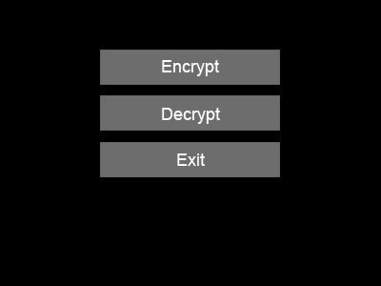

*Figure 4 – Main Menu*

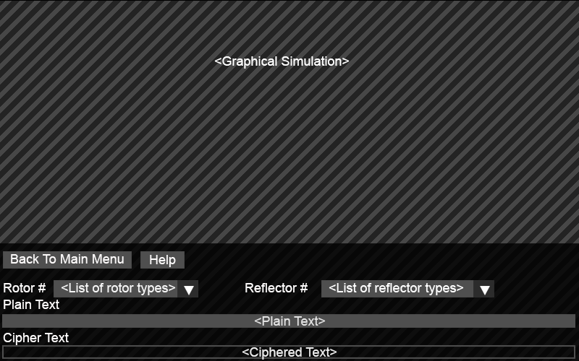

*Figure 4.1 - Encrypt*

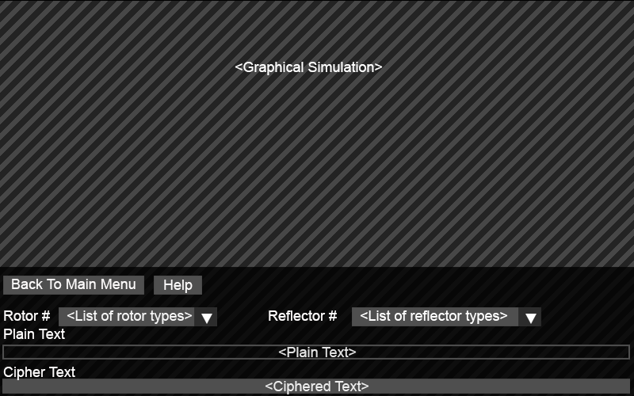

*Figure 4.2 – Decrypt*

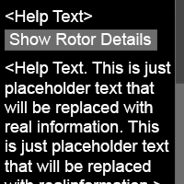

*Figure 4.3 – Help*

From figures 4.1 and 4.2 we can see that some features were added to the initial design concepts. In addition, the space for the simulation has been increased vastly. This design decision was made because it was thought that this amount of space should be enough for the user to view the simulation in enough detail. The user will now be able to choose a reflector setting as well as rotor settings. Also a help button has been included. This will present a semi-transparent pop up window which will contain information about the process of the encryption and decryption methods. It shall also contain the controls necessary for the user to manipulate their view of the simulation.

Figure 4.3 shows the help screen which will be populated with text which the user can refer to for guidance and a button which will present the user with an image of a complete rotor with details of each component.